Penpych Community Primary School

School Development Plan

2022-2023

School Development Plan

Vision and Context:
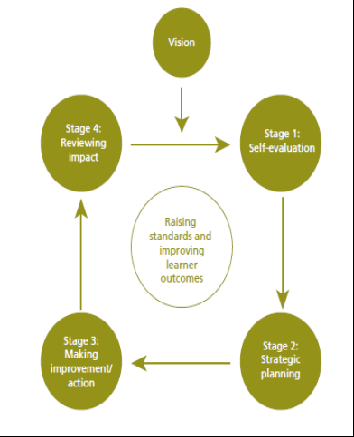
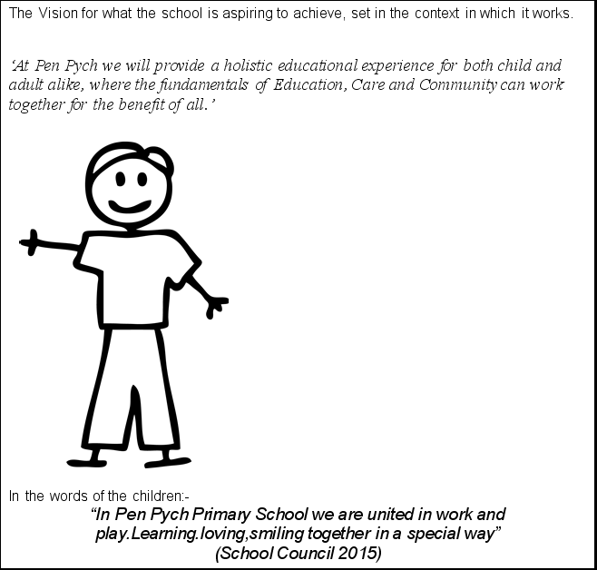

Year Strategic Overview 2020-2023

(Priorities are subject to change if necessary to respond to changing need)

2020-21 – Aims & Aspirations: | 2021-22- Aim & Aspirations | 2022-23- Aim & Aspirations
Revised due to *CoVid Pandemic school / class closures  Priority 1 – Deliver basic skills in Literacy and Numeracy  Priority 2 – Learning – Blended Learning approaches + New Curriculum Wales  Priority 3 – ALN Bill preparations - Sustain + Support Wellbeing for all stakeholders - WRAP approaches + resilience  *CoVid Pandemic school / class closures | Priority 1-To ensure that effective provision to support the well-being of pupils and staff enables progress and achievement in the C-19 recovery context  Priority 2(a)- To begin the design process which ensures that the new curriculum (CFW) is thoroughly prepared for, relevant and meets the needs of every pupil in our school .  Priority 2(b)-To Ensure that nearly all pupils make at least expected progress in Literacy/Mathematics or LLC/MD in relation to their baseline in Autumn 2021  Priority 3-To establish and implement an effective process for meeting the needs of pupils with ALN in line with the requirements of national reform  Priority 4-To ensure that leaders at all levels, including the interim SLT, are enabled to carry out their roles effectively | Priority 1 - To ensure that effective provision to support the well-being of pupils and staff  Priority 2 – To ensure that there is a shared commitment to improving Oracy and Writing for all children.  Priority 3 – To ensure that there is a purposeful authentic curriculum to engage and motivate our young children encouraging them to be leaders in their community and the wider world.  Priority 4- To build a holistic tracking and assessment with a particular focus on raising attainment for disadvantage learners.  Priority 5-To continue to inbed effective process for meeting the needs of pupils with ALN in line with the requirements of national reform

